Main Puzzle Mechanic

Overview

The main segment of the game will be the player trying to decipher memories that are related to the wife and the main character. The player does this by completing a sliding puzzle (as shown below):

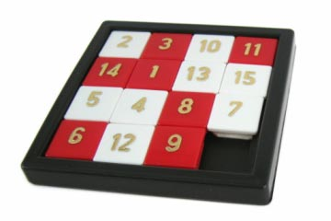

Annotated Concept

 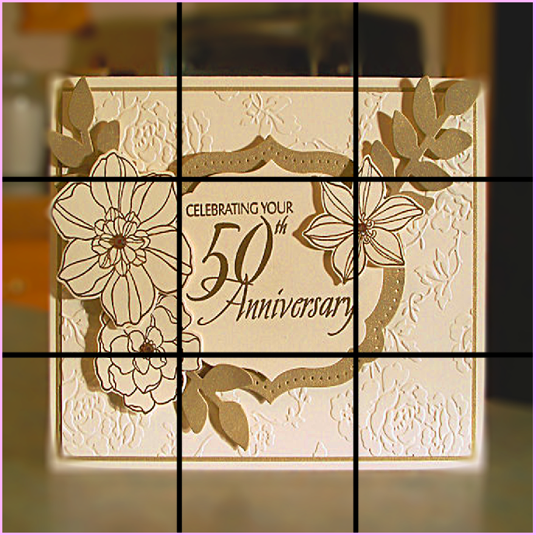

Figure 2: The code will split up the picture into a grid (as shown above as a 3x3 grid)

Figure 1: This is the picture we would use for the sliding box puzzle



The bottom right tile will be gone until the player completes the remainder of the picture. Once all pieces are in place the last piece will appear for players to see the picture.

Figure 3: Players will have to put the picture back together to see the picture and to progress through





Figure 4: The player can move any tile adjacent to the blank square into the space; however they cannot move a tile picture piece onto another tile picture piece.

Difficulty

The sliding box puzzle will increasingly get more difficult as the player progresses through the game. Since the game is split into 7 segments, the player will do a total of 5 sliding box puzzles:

1. First memory– teaches players how to do it and what they must do (in the form of a 3x3 grid)
2. Second memory – Players will be aware of The Carer walking around the house and will be warned that they must not be caught in the puzzle whilst doing the puzzle box. Grid stays as a 3x3.
3. Third memory – The grid of the sliding puzzle will now be a 4x4 which means there are more pieces to sort out. Players will also be more aware of a countdown timer of which the furniture in rooms will start to rotate including the position of the memory item, however will find that their progress will not be lost.
4. Fourth memory – No changes to the puzzle itself, however the upstairs rooms are unlocked for it to spawn in possibly
5. Fifth memory – final puzzle box, will be upstairs. The grid will change to a 5x5 which will be the hardest puzzle yet.